Appendix 2 Prior distributions

Exogenous AR shocks have beta distributions for auto-correlation coefficients with prior mean at 0.85 except for the monetary shock, where we set prior mean to 0.5 (i.e. we did not have any ‘preference’ between a persistent shock or a white noise) and for the overhead labour shock, where we set prior mean to 0.95. Standard errors have prior gamma distributions, with prior mean values at
- 0.5% for ‘persistent shocks’ (accounting for different trends in the data, like overhead labour,) and for shocks to risk premia;
- 0.25% for monetary shock;
- 5% for technology shock, preference and adjustment costs shocks, nominal GDP shares of government consumption, investment, transfers;
- 10% for mark-up shocks

For the fiscal parameters, we set a prior around zero for τ^{CG} and τ^{IG}, to let the data drive pro-cyclical or counter-cyclical reaction of government consumption and investment to changes in the output gap. For transfers we also set a neutral prior mean of b^{U} at 0. Persistence in the government spending rule has a prior at 0.5, while for investment and transfers this is set to 0.85.

For price and wage rigidities we follow Smets and Wouters (2003), but allow for a wider variation in the upper bound (prior mean at 30). Capital and labour adjustment costs have similar priors, while for investment the prior is smaller (15). Prior consumption and leisure habits are set at 0.7. Inverse of intertemporal elasticities have prior gamma distributions with mean 1.25 and standard deviation 0.5 (2 and 1 for 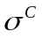). The share of liquidity constrained households has a neutral prior at 0.5, with standard deviation 0.1, similar to Forni et al. (2006). Finally, the share of forward looking behaviour in hybrid Phillips curves and the price indexation coefficients in import and export equations have prior mean at 0.5 in the range [0, 1].

Mapping acceptability of the prior domain.

The prior assumptions used for the Bayesian estimation have been preliminary checked, to assess the acceptability domain of the model within the prior space, i.e. to detect the occurrence of unstable behaviour of indeterminacy. This is performed following the Monte Carlo Filtering approach shown in Ratto (2008). We generated a Monte Carlo sample of model parameters from prior distributions and for each element of the sample we have checked the rank condition for the eigenvalues of the linearised model. This analysis showed that 94.4% of the prior domain is acceptable, 5.1% of the prior domain provides explosive solutions while only a 0.4% gives indeterminacy. The large portion of the acceptability domain allows us to state that our prior space is well defined and subsequent posterior update is not affected by large portion of violations of Blanchard Kahn conditions.

Concerning the explosive behaviour, sensitivity analysis showed that this is mostly driven by
- too small values of sfp, sfpx and sfw;
- too small values for 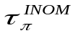;
- too large values of 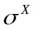;
- large negative values of 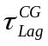.

Estimation details

TABLE A2: Estimation Results for exogenous shocks

Parameter name |  | Prior |  |  |  |  |  | Posterior
 |  | distrib |  | mean |  | std |  | mean |  | std
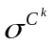 |  |  | gamma |  | 0.05 |  | 0.03 |  | 0.0597 |  | 0.0107
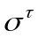 |  |  | gamma |  | 0.1 |  | 0.06 |  | 0.15 |  | 0.0246
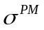 |  |  | gamma |  | 0.02 |  | 0.015 |  | 0.0202 |  | 0.0038
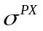 |  |  | gamma |  | 0.1 |  | 0.06 |  | 0.0648 |  | 0.0355
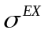 |  |  | gamma |  | 0.005 |  | 0.03 |  | 0.0044 |  | 4.37E-04
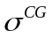 |  |  | gamma |  | 0.05 |  | 0.03 |  | 0.0048 |  | 3.46E-04
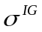 |  |  | gamma |  | 0.05 |  | 0.03 |  | 0.0056 |  | 4.17E-04
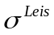 |  |  | gamma |  | 0.05 |  | 0.03 |  | 0.0283 |  | 0.0078
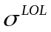 |  |  | gamma |  | 0.005 |  | 0.003 |  | 0.0048 |  | 0.001
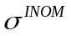 |  |  | gamma |  | 0.003 |  | 0.0015 |  | 0.0013 |  | 9.88E-05
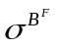 |  |  | gamma |  | 0.005 |  | 0.003 |  | 0.0017 |  | 2.40E-04
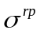 |  |  | gamma |  | 0.005 |  | 0.003 |  | 0.007 |  | 0.0017
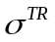 |  |  | gamma |  | 0.05 |  | 0.03 |  | 0.0022 |  | 1.57E-04
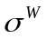 |  |  | gamma |  | 0.05 |  | 0.03 |  | 0.0437 |  | 0.0156
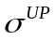 |  |  | gamma |  | 0.05 |  | 0.03 |  | 0.0121 |  | 0.0013
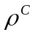 |  |  | beta |  | 0.85 |  | 0.075 |  | 0.9144 |  | 0.0295
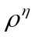 |  |  | beta |  | 0.5 |  | 0.2 |  | 0.1095 |  | 0.0771
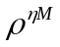 |  |  | beta |  | 0.85 |  | 0.075 |  | 0.9557 |  | 0.0164
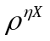 |  |  | beta |  | 0.85 |  | 0.075 |  | 0.8109 |  | 0.0668
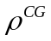 |  |  | beta |  | 0.5 |  | 0.2 |  | 0.2983 |  | 0.1
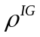 |  |  | beta |  | 0.85 |  | 0.075 |  | 0.853 |  | 0.0797
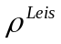 |  |  | beta |  | 0.85 |  | 0.075 |  | 0.975 |  | 0.0159
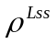 |  |  | beta |  | 0.95 |  | 0.02 |  | 0.9334 |  | 0.0188
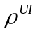 |  |  | beta |  | 0.5 |  | 0.2 |  | 0.6652 |  | 0.1409
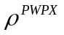 |  |  | beta |  | 0.5 |  | 0.2 |  | 0.2159 |  | 0.0686
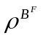 |  |  | beta |  | 0.85 |  | 0.075 |  | 0.9842 |  | 0.0103
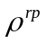 |  |  | beta |  | 0.85 |  | 0.075 |  | 0.9148 |  | 0.0233
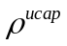 |  |  | beta |  | 0.95 |  | 0.02 |  | 0.9517 |  | 0.0187
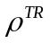 |  |  | beta |  | 0.85 |  | 0.075 |  | 0.8636 |  | 0.0428

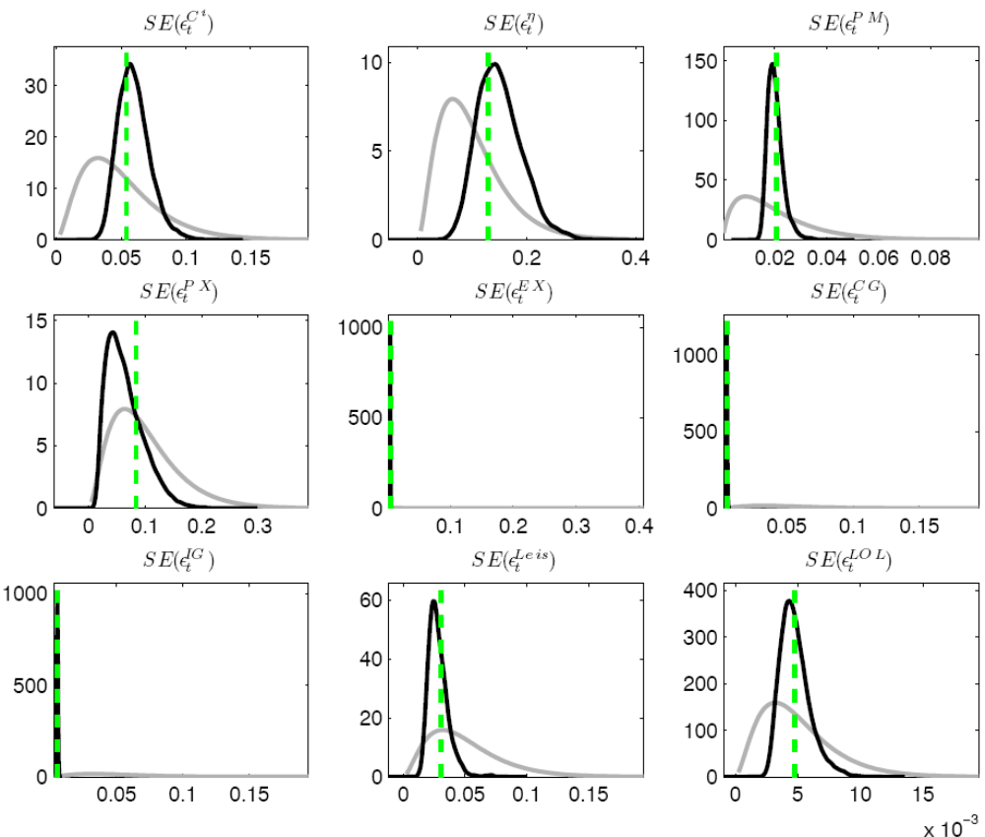
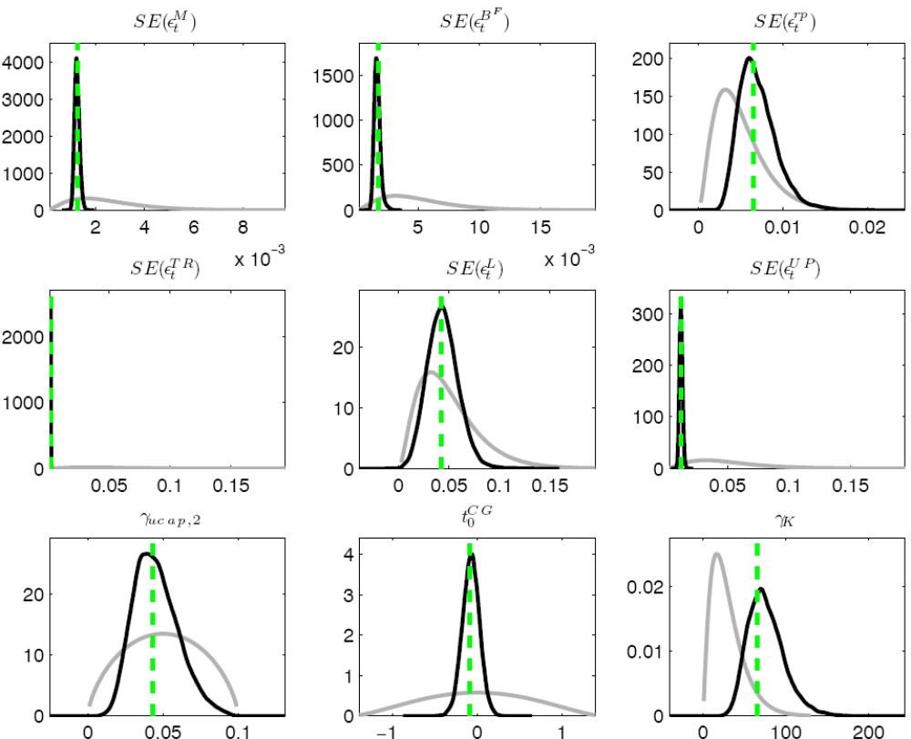
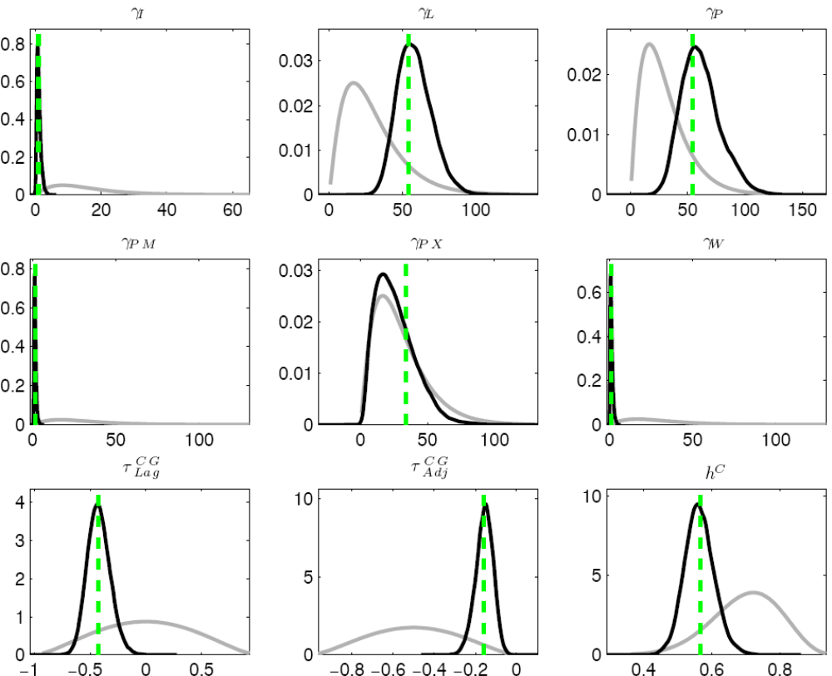
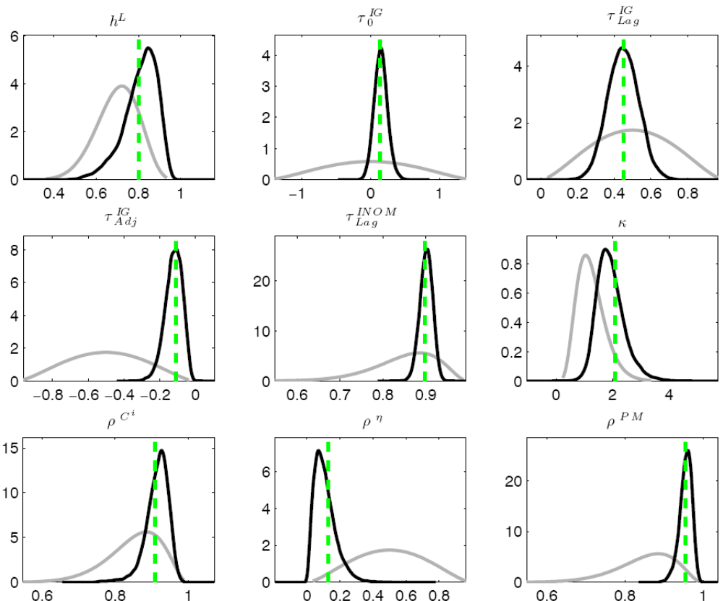
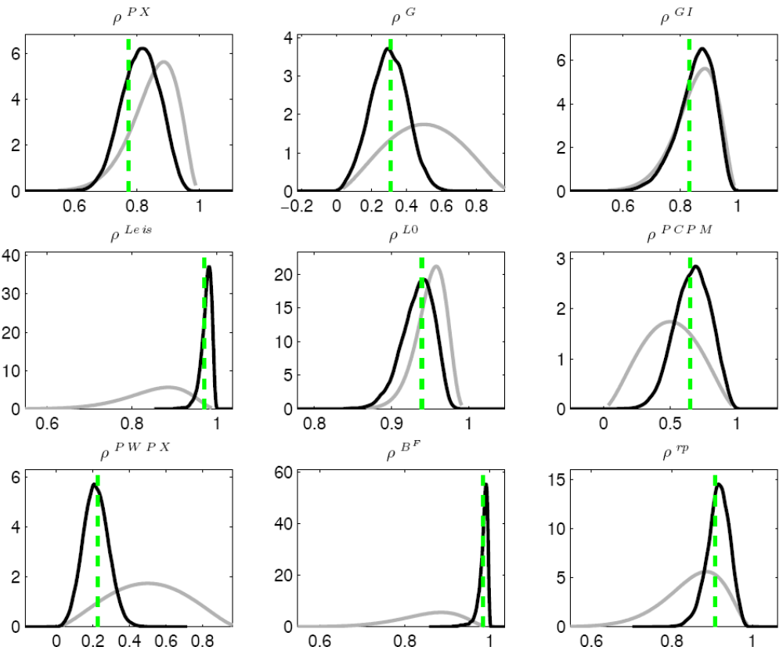
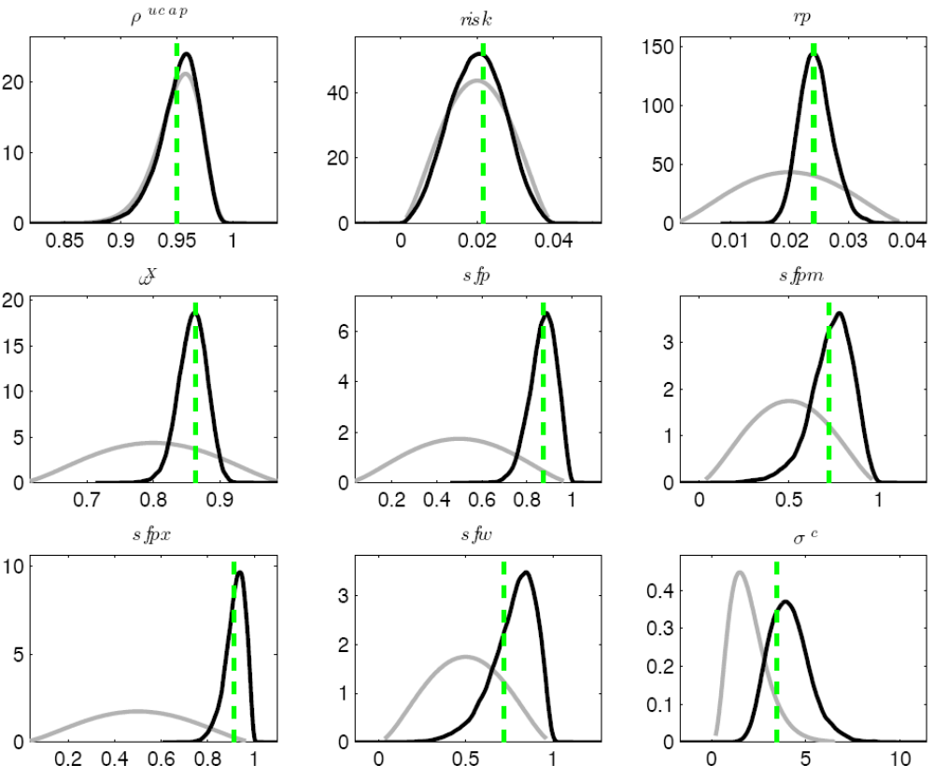
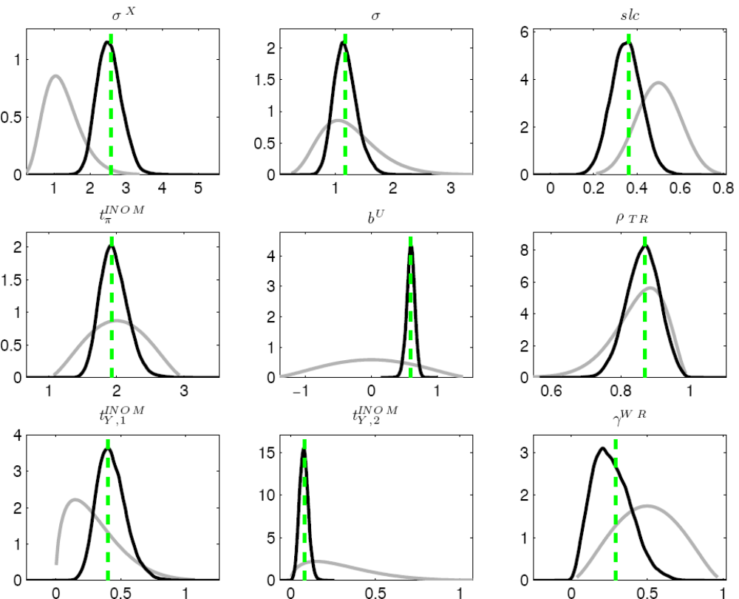

FIGURE A2. Prior distributions (grey lines), posterior distributions (black lines) and posterior mode (dotted lines) of the estimated parameters.
References

Ratto, M., 2008. Analysing DSGE models with Global Sensitivity Analysis, Computational Economics 31, 115-139.

